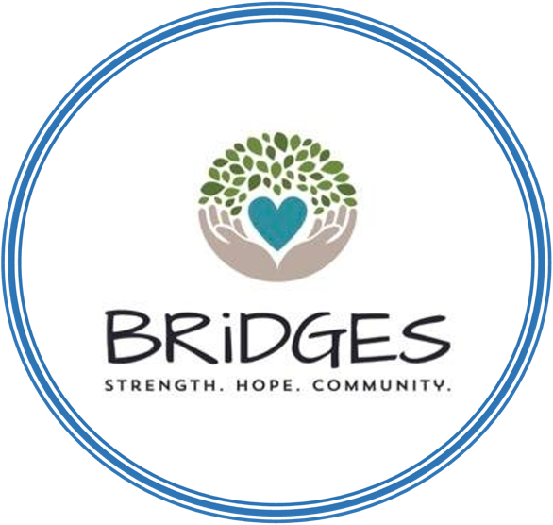

BRiDGES Asks the Community:

What does wellness mean to you?

How do you practice wellness during the workday?

Who inspires you on your wellness journey?

How do you manage your feelings when you feel stressed, frustrated and/or unhappy? (This can be at home or at work)

How do you de-stress and/or unwind after a day at work?

Are you happy with your life at this very moment? Why or why not? What is a single step you could take that would move you towards being happier?

What’s Going Well In Your life? Any Wins This Week/Month?

What’s Your Biggest Challenge Right Now?

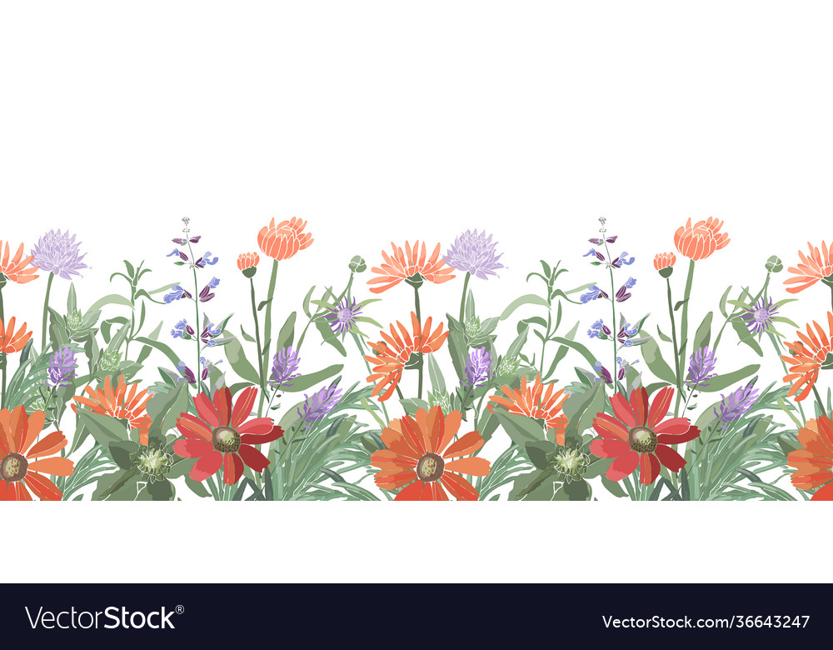

**Wellness questions to ask ourselves:**

How do I feel at this moment? Both mentally and physically?

What is taking up most of my headspace at the moment?

What or who makes me happiest? Why?

What will I engage in today to bring myself joy?

What am I most committed to? Why am I committed to it?

Who or what inspires me the most?

Do I have enough quiet time with myself?

When was the last time I ate a full meal?

What am I looking forward to? What am I the most excited about?

What do I love most about myself? What is my best characteristic?

What am I grateful/thankful for today?

What is one thing I can do today to help me achieve my long-term goals?

